DPM Group_6 lab5 hardware design 1.0

Yuhang Zhang Feb.18

**Objective:**

To locate cans that are placed in a grid system and distinguish its color.

**Hardware Basis:**

* 2 us sensors: 2-D distance detection
* 2 color sensors: odometer and color detection respectively
* Robot chassis
* Rotating color sensor system

**How to achieve:**

1. To place the robot at the corner (0, 0) of the grid system.
2. Input the length and width of such a system that the robot knows the system’s size and shape.
3. At (0,0) position, 2 us sensors tell the robot if there is an obstacle on (0, y) and (x, 0) axis. Moreover, the robot is able to understand the obstacle’s exact position: ((distance/30.48), 0).
4. The robot travels to the obstacle ((distance/30.48), 0) and stops before crushed. It collects and records the color by the ***rotating color sensor [1]*.**
5. The same procedure will be continued by (x, 1) (x, 2) until y reaches the (input width/30.48).
6. The robot will be travelling to the opposite corner (length, width), repeating step 3~5
7. Finished and LCD display

[1] the reason to use ***rotating color sensor***:

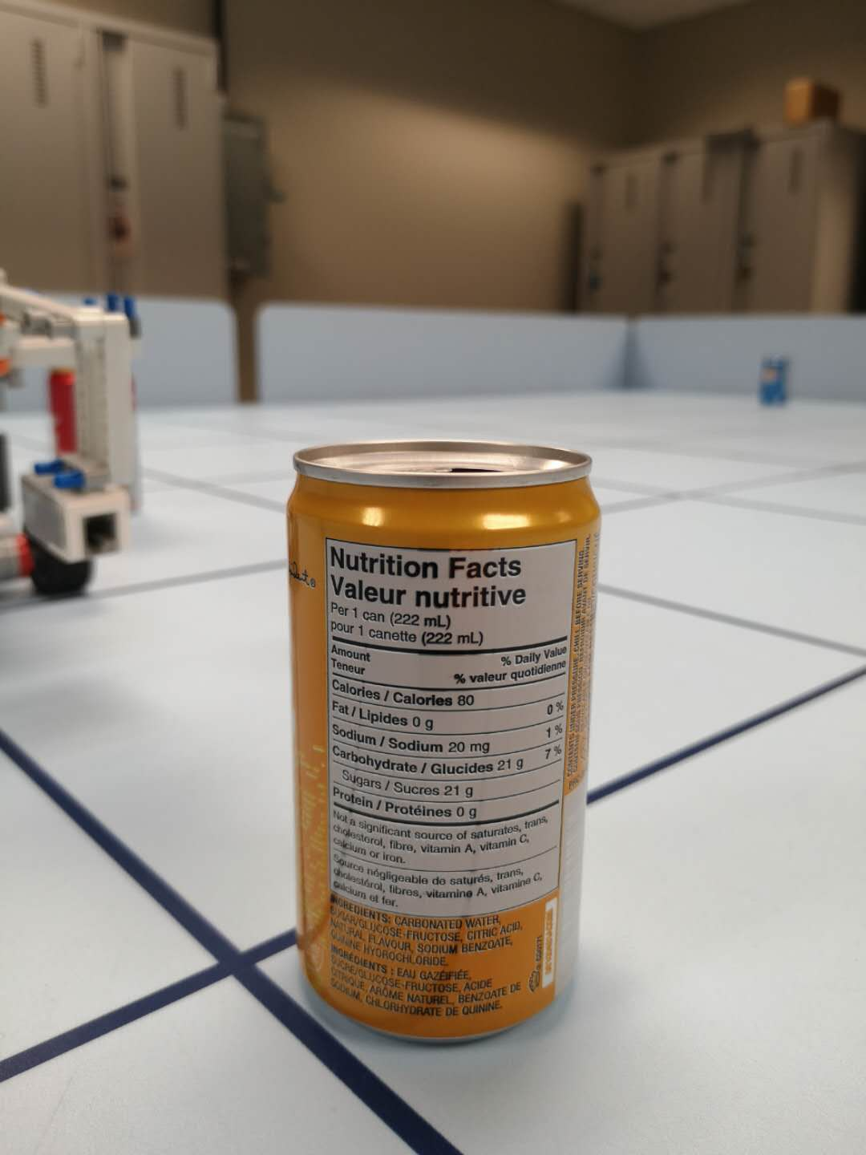

Shown in Figure1, to avoid a tricky case that undesired color is placed in front of a fixed color sensor.

***Rotating color sensor*** allows color values are collected 270 degree consecutively and excludes the extreme case.

Figure. 1

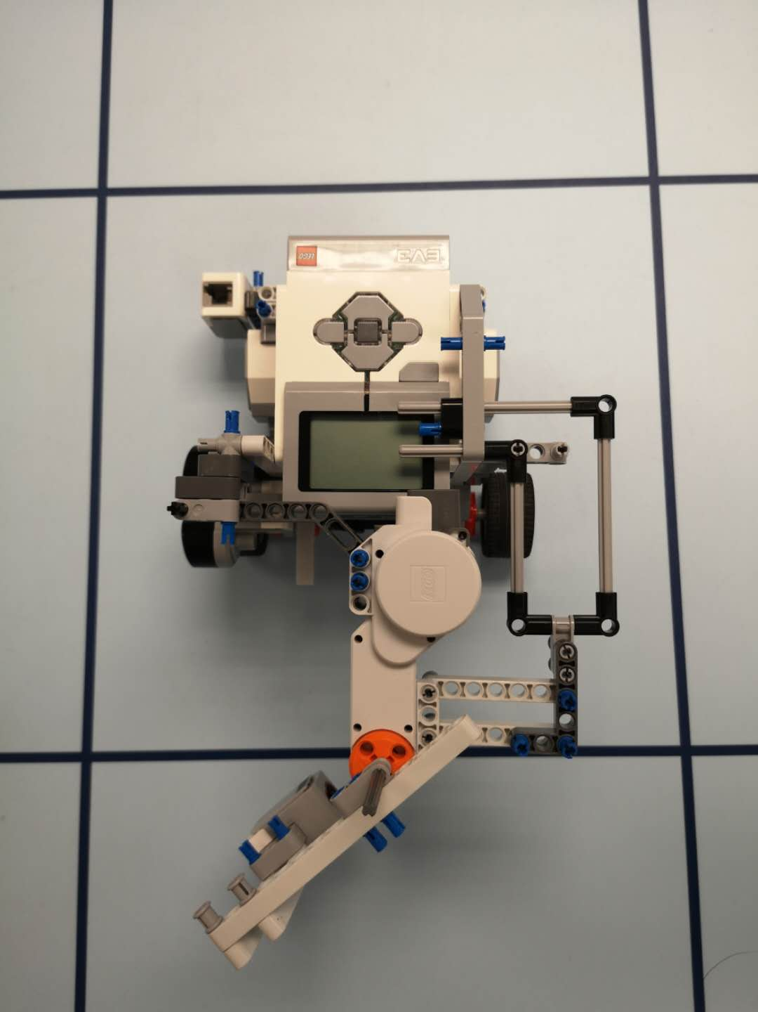**Robot design:**

